EXPERIMENT 7 ATTENDANCE PERCENT

Step1:Create an application called ‘Student Attendence’

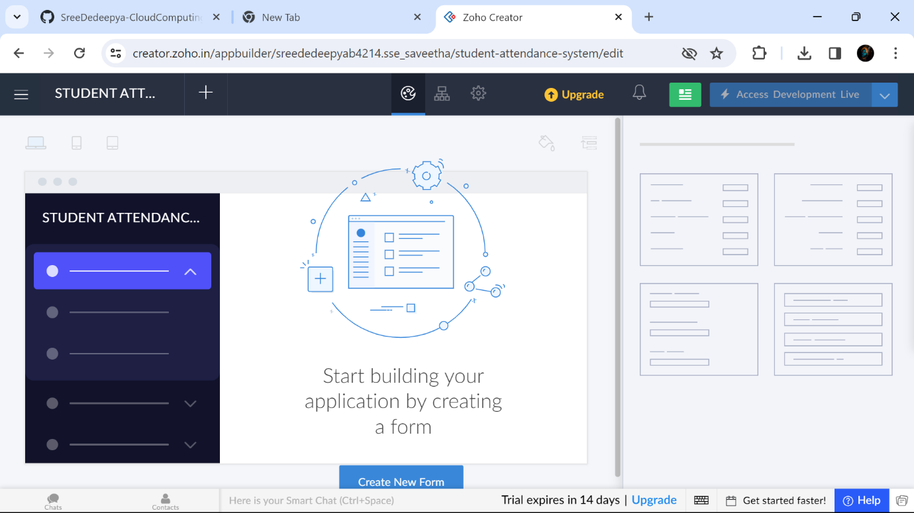

Step2:Creating a form called ‘Student Details’

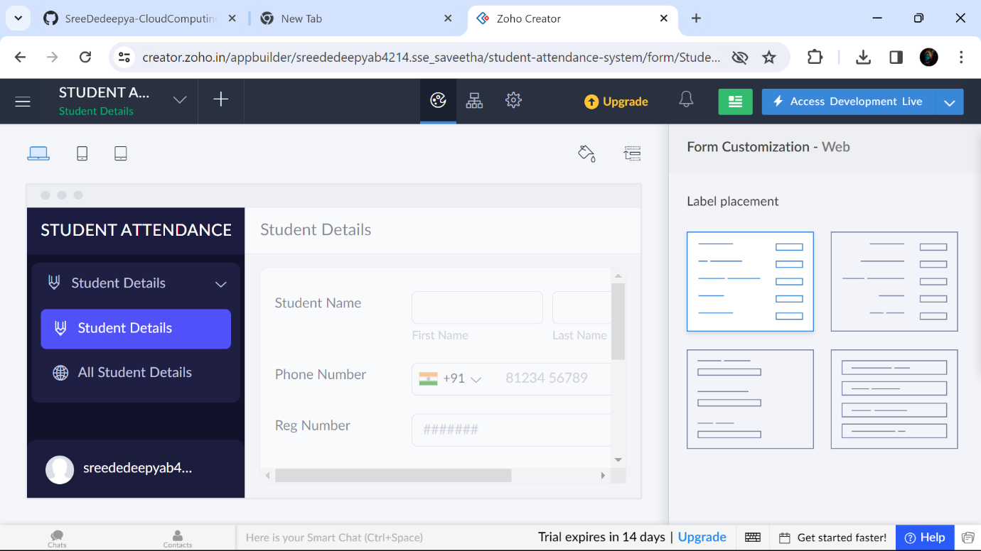

Step3 :Creating a form called ‘Attendence Details’

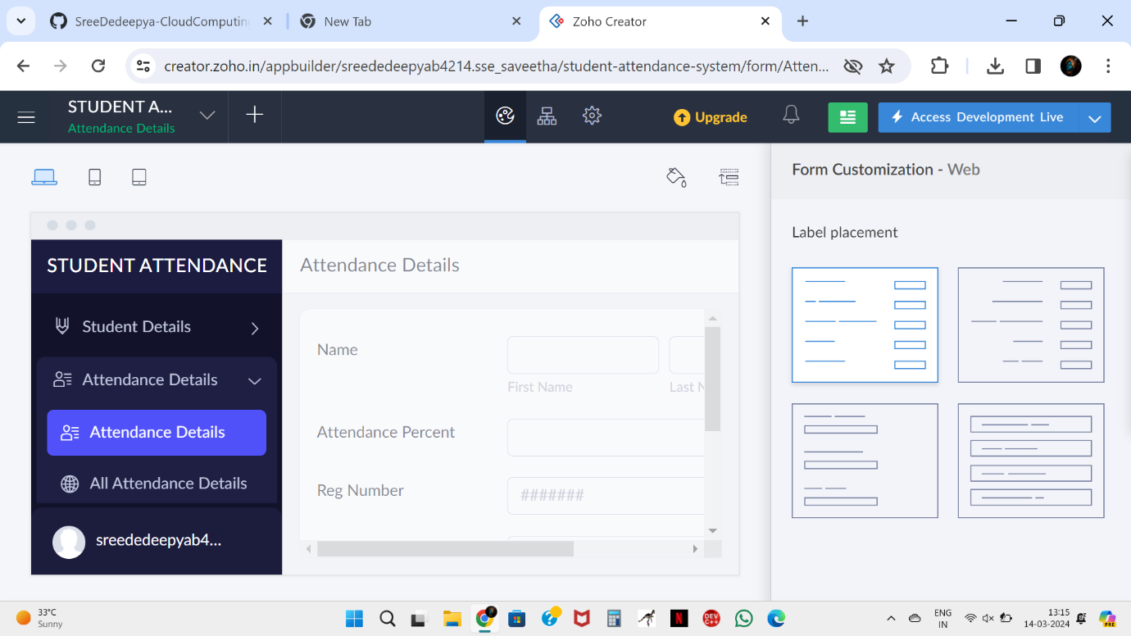

Step4:Creating a form called ‘CourseDetails’

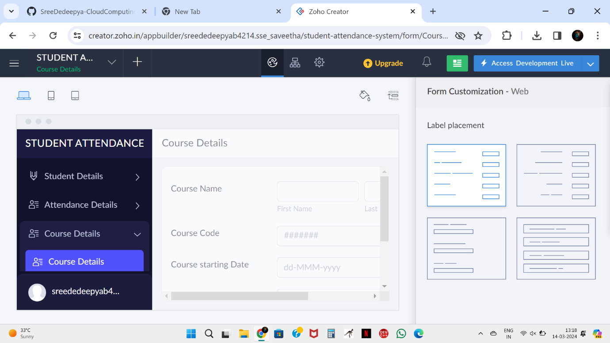

Step5:Displaying the details in ‘Student Details’

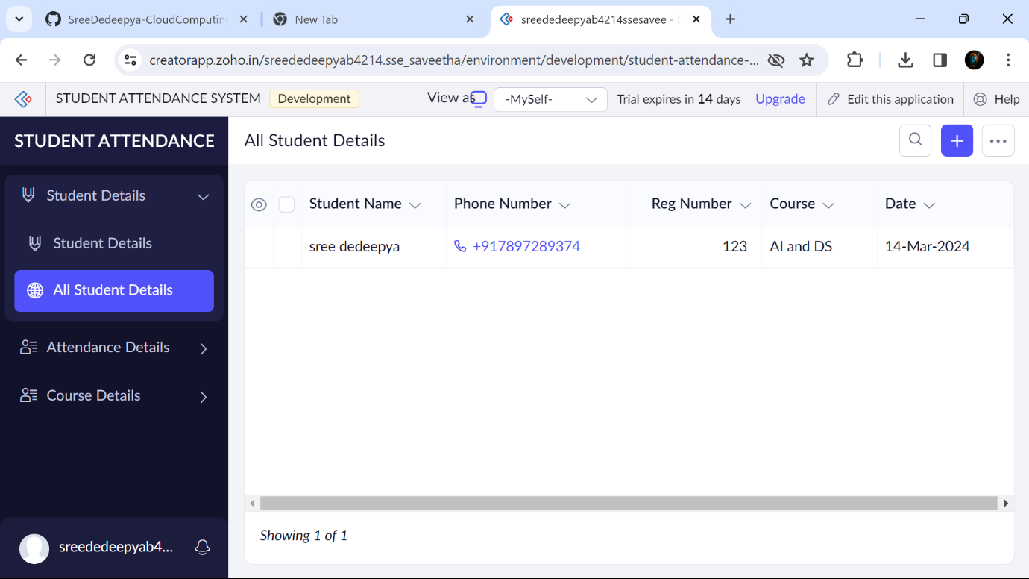

Step6:Displaying the details entered in ‘Attendance Details’

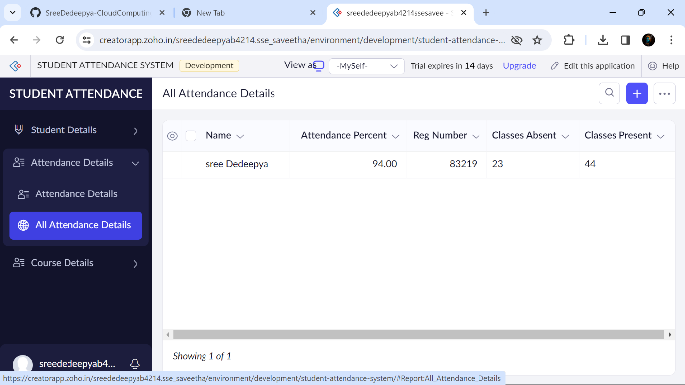

Step7 :Displaying the details entered in ‘CourseDetails’

